Level 1 Qns Topic:- Class Methods and Constructors

Jenny is addicted

Bappana is working

central government tall booth

bhagavan the Government school teacher

fahrad is the owner of the biggest super market

Rahul and Kuldeep plays a mathematical

Vikran has hais own lake

Yohan very much likes gifts

Rohan is an ethusiastic guy

aththya karthalan the chola king

Tamilnadu land registration

Abhilash wants to save money

Tamilnadu Educational Minister has ordered the Director of HE

Hassan Works for the Popular Telecommunication

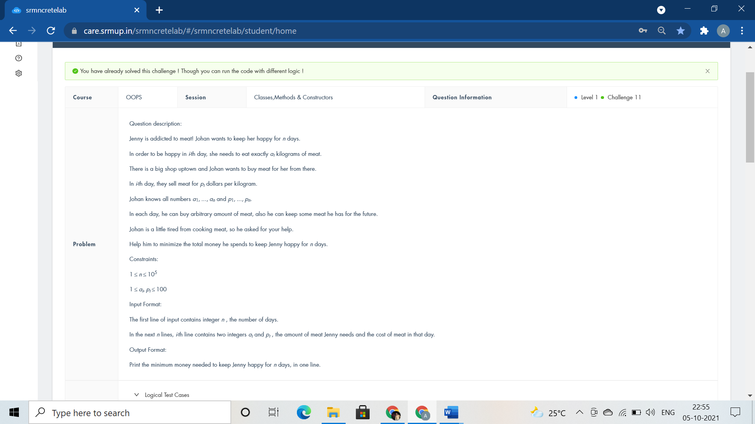

#include <iostream>

using namespace std;

class Happiness{

public:int Meat(){

int n,a,b,max=100,sum=0;

cin>>n;

while(n--)

{

cin>>a>>b;

//max=b;

if(b>=max)

sum+=a*max;

// cout<<max<<endl;

// cout<<sum<<endl;

else

{

max=b;

sum+=a*b;

// cout<<max<<endl;

// cout<<sum<<endl;

}

}

return sum;

}

};

int main(){

Happiness Purchase;

cout<<Purchase.Meat();

}

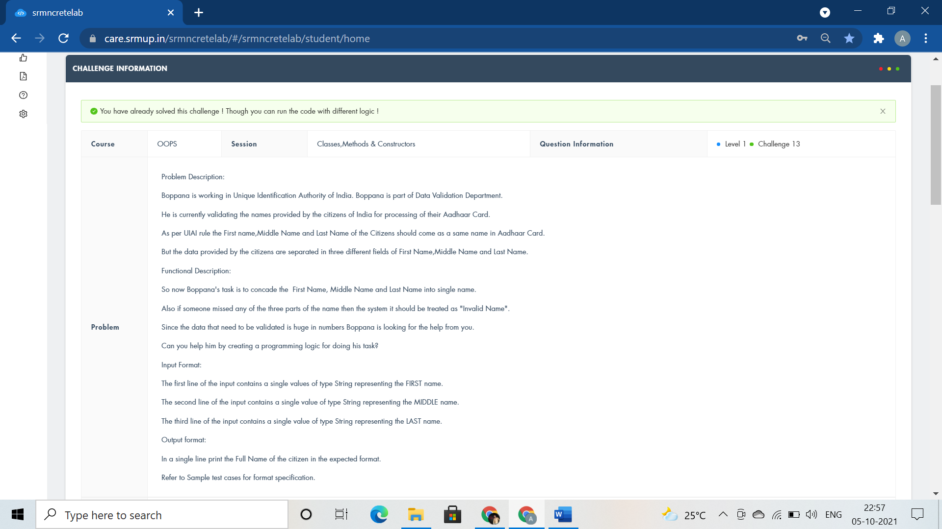

#include <iostream>

#include<cstring>

#include<string>

using namespace std;

class aadhaar

{

public:

void NameofCitizen(string fn,string mn,string ln)

{

if(fn.empty() || mn.empty() || ln.empty() )

{

cout<<"Invalid Name";

}

//cout<<"Invalid name"; exit(0) :

else

cout<<fn<<mn<<ln;

}

};

int main()

{

aadhaar Card;

string fn,mn,ln;

cin>>fn>>mn>>ln;

Card.NameofCitizen(fn,mn,ln);

return 0;

}

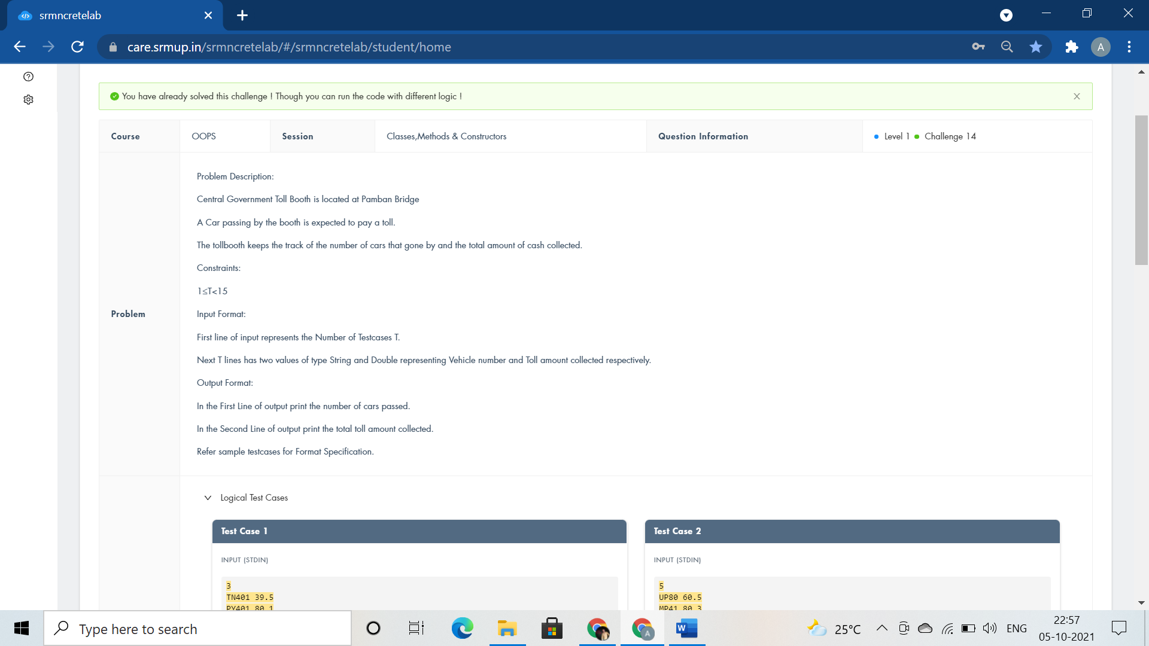

#include <iostream>

using namespace std;

class TollBooth

{

public:

int cars;

float tollcollected;

TollBooth(){

cars=0;

tollcollected=0;

}

void payingcar(double pay){

cars++;

tollcollected+=pay;

}

void nonpayingcar(){

cars++;

}

void display(){

cout<<cars<<endl<<tollcollected<<endl;

}

};

int main()

{

TollBooth obj;

char VehicleNo[10];

float TollAmt;

int carpassed,i;

cin>>carpassed;

for(i=0;i<carpassed;i++)

{

cin>>VehicleNo>>TollAmt;

if(TollAmt>0) obj.payingcar(TollAmt);

else obj.nonpayingcar();

}

obj.display();

return 0;

}

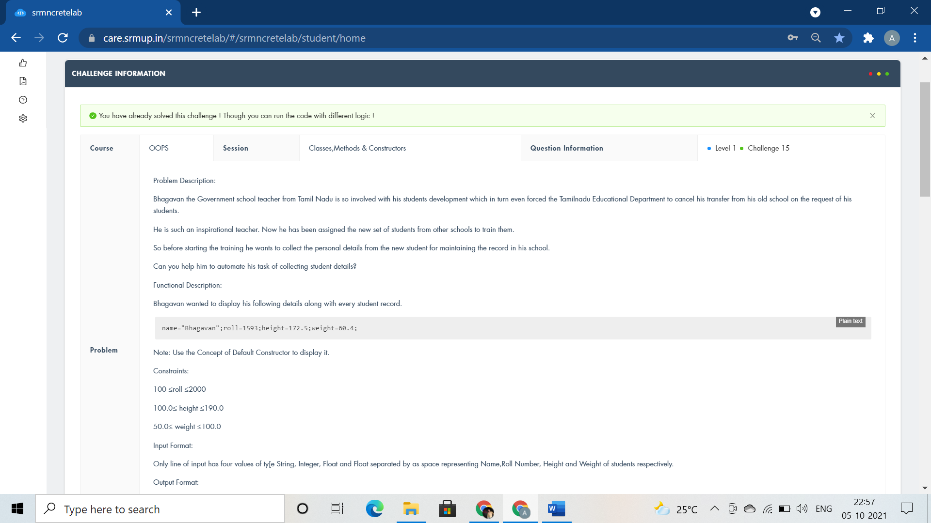

#include <bits/stdc++.h>

//#include<iomanip>

//#include<string>

using namespace std;

class student

{

string name;

int roll;

float height,weight;

public:

student(){name="Bhagavan";roll=1593;height=172.5;weight=60.4;}

void getdata() {

cin>>name>>roll>>height>>weight;

}

void displaydata(){

cout<<name<<" "<<roll<<" "<<height<<" "<<weight<<endl;

}

};

int main()

{

student s1,s2;

s1.getdata();

s1.displaydata();

s2.displaydata();

return 0;

}

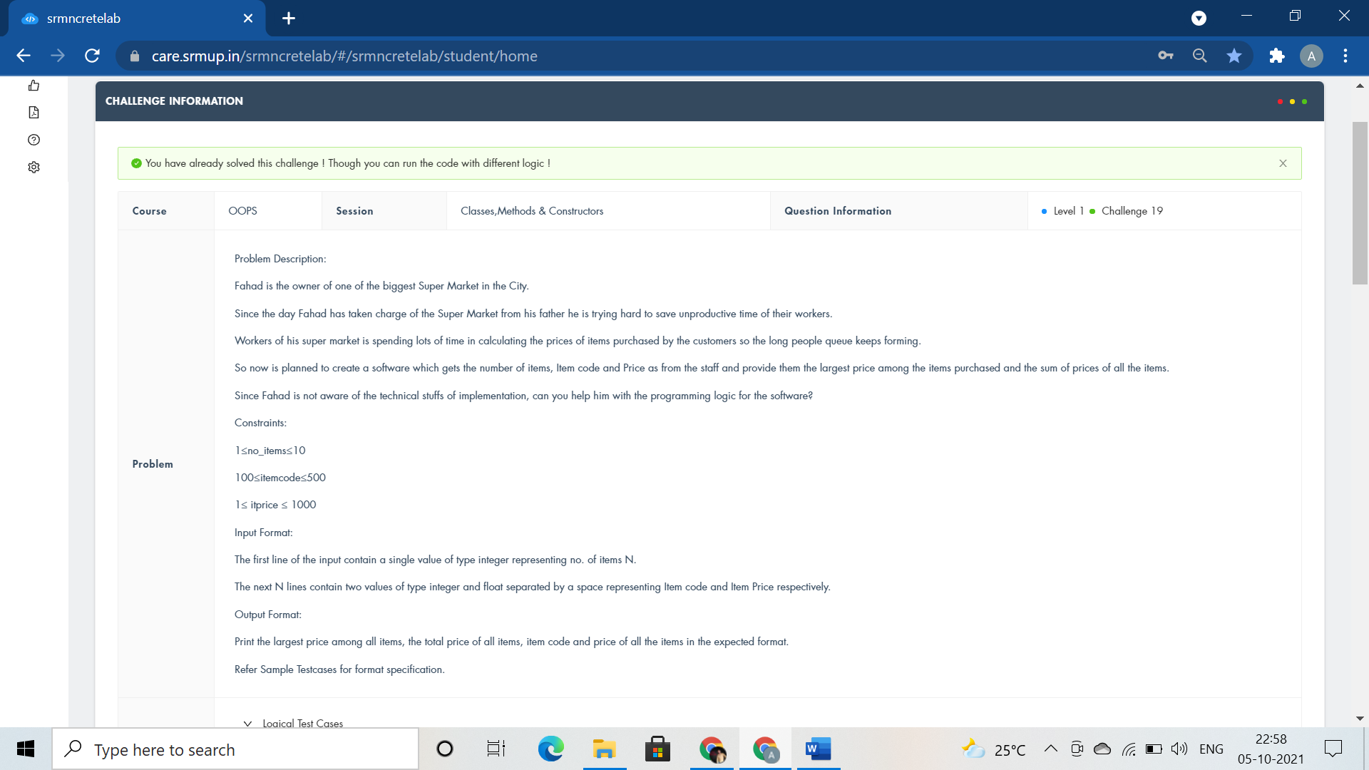

#include <iostream>

using namespace std;

class ITEM

{

public:

int n;

float large=0,summ=0;

float arr[100],code[100];

void getdata(int b){

n=b;

for(int i=0;i<n;i++)

cin>>code[i]>>arr[i];

}

void largest(){

for(int i=0;i<n;i++)

{

if(arr[i]>=large)

large=arr[i];

}

}

void sum(){

for(int i=0;i<n;i++)

summ+=arr[i];

}

void displayitems(){

cout<<"Largest Price="<<large<<endl;

cout<<"Sum of Prices="<<summ<<endl;

cout<<"Code and Price"<<endl;

for(int i=0;i<n;i++)

cout<<code[i]<<" and "<<arr[i]<<endl;

}

};

using namespace std;

int main()

{

ITEM order;

int b;

cin>>b;

order.getdata(b);

order.largest();

order.sum();

order.displayitems();

return 0;

}

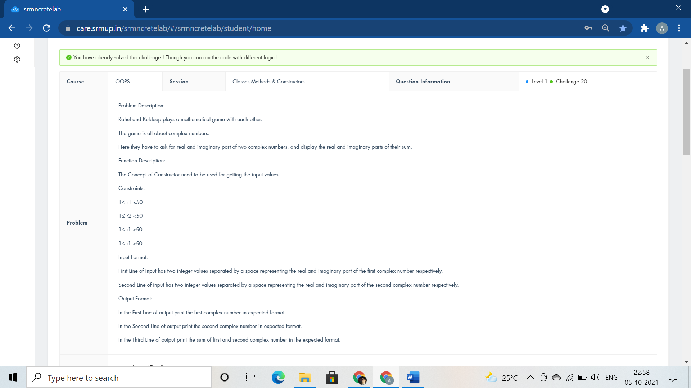

#include<iostream>

using namespace std;

class Complex{

public:

int r1,i1,r2,i2,r3,i3;

Complex(){cin>>r1>>i1;cin>>r2>>i2;}

void addcomplex(){

r3=r1+r2;

i3=i1+i2;

}

void displaycomplex(){

cout<<r1<<"+"<<i1<<"i"<<endl;

cout<<r2<<"+"<<i2<<"i"<<endl;

cout<<r3<<"+"<<i3<<"i"<<endl;

}

};

int main(){

Complex calculate;

calculate.addcomplex();

calculate.displaycomplex();

return 0;

}

#include <iostream>

#include <string.h>

#include <stdio.h>

using namespace std;

double a[18][18], b[1 << 18];

int fun(int x) {

int s = 0;

while (x)

{

s += x & 1;

x >>= 1;

}

return s;

}

int main() {

if(0)

cout<<"class Lake public:void survival() fish.survival();";

int n, i, r, t, j;

cin >> n;

for (i = 0; i < n; i++)

for (j = 0; j < n; j++)

scanf("%lf", &a[i][j]);

memset(b, 0, sizeof(b));

b[(1 << n) - 1] = 1;

for (i = (1 << n) - 1; i >= 0; i--) {

int c = fun(i);

c = c * (c - 1) / 2;

for (r = 0; r < n; r++)

if (i & (1 << r))

for (t = 0; t < n; t++)

if (i & (1 << t))

b[i - (1 << t)] += b[i] * a[r][t] / c;

}

for (r = 0; r < n - 1; r++)

printf("%.6lf ", b[1 << r]);

printf("%.6lf\n", b[1 << r]);

}

#include <iostream>

using namespace std;

class Friends

{

public:void Gifts(){

int i, n, a, b[50] = { 0 };

cin >> n;

for (i = 1; i < n+1; i++)

{

cin >> a;

b[a] = i;

}

for (i = 1; i < n+1; i++)

cout<< b[i]<<" ";

}

};

int main()

{

Friends Sharing;

Sharing.Gifts();

}

#include <iostream>

using namespace std;

class GoodNum

{

public:

void check(int tNum)

{

int cnt=0;

int rem;

while(tNum>0)

{

rem=tNum%10;

if(rem==0)

cnt++;

tNum/=10;

}

if(cnt==0)

cout<<"GOOD Number"<<endl;

else

cout<<cnt;

}

};

int main(){

int N;

cin>>N;

GoodNum Learning;

Learning.check(N);

return 0;

}

#include <iostream>

#include <math.h>

using namespace std;

class Building

{

public:

int length, width, ratePerSqFeet;

void calculateCost()

{

int i,j,k,z;

cin>>i>>j>>k;

length=i;

width=j;

ratePerSqFeet=k;

z=length*width*ratePerSqFeet;

cout<<"Cost of the Building : "<<z<<endl;

}

void determineSuitability()

{

if(length==70||length==410)

{

cout<<"Stability : Suitable";

}

else if(abs(length-width)<10)

{

cout<<"Stability : Suitable"<<endl;

}

else

{

cout<<"Stability : Not Suitable"<<endl;

}

}

};

int main()

{

Building construction;

construction.calculateCost();

construction.determineSuitability();

return 0;

}

#include <iostream>

using namespace std;

class address

{

int hno;

char cty[20];

char state[20];

public:

void getad()

{

cin>>hno>>cty>>state;

}

void putad()

{

cout<<"House No="<<hno<<endl;

cout<<"City="<<cty<<endl;

cout<<"State="<<state<<endl;

}

};

class house

{

char housename[30];

address a;

int n;

public:

void input();

};

void house::input()

{

cin>>housename;

cout<<"House name="<<housename<<endl;

a.getad();

a.putad();

cin>>n;

int lenght,widht,height;

for (int i = 0; i < n; i++)

{

cin>>lenght>>widht>>height;

cout<<"Detail of Room "<<i+1<<endl;

cout<<"Length="<<lenght<<endl;

cout<<"Breadth="<<widht<<endl;

cout<<"Height="<<height<<endl;

}

}

int main() {

if(0)

{

cout<<"void house::display()";

}

house x;

x.input();

return 0;

}

#include <iostream>

using namespace std;

class Bank

{

int total;

public:

void totalMoney(int n)

{

int r;

r = n%7;

n/=7;

total =(n*(49+(7*n)))/2 + r*(2*(n+1)+r-1)/2;

cout<<total;

}

};

int main(){

int n;

cin>>n;

Bank CalculateMoney;

CalculateMoney.totalMoney(n);

return 0;

}

#include <iostream>

using namespace std;

class student

{

string name;

int roll;

float height, weight;

public:

student(){name="Bhagavan";roll=1593;height=172.5;weight=60.4;}

void set_data()

{

cin>>name>>roll>>height>>weight;

}

void displaydata()

{

cout<<name<<" "<<roll<<" "<<height<<" "<<weight<<endl;

}

};

int main()

{

student s1,s2;

s1.set_data();

s1.displaydata();

s2.displaydata();

return 0;

}

#include <iostream>

using namespace std;

class Phone

{

public:

char n[14];

void change()

{

cin>>n;

n[0]='1';

cout<<'9'<<n;

}

};

int main()

{

Phone obj;

obj.change();

return 0;

}